Robert Thompson

2/6/2025

IT-230

SNHU

5-2 Final Project Part I

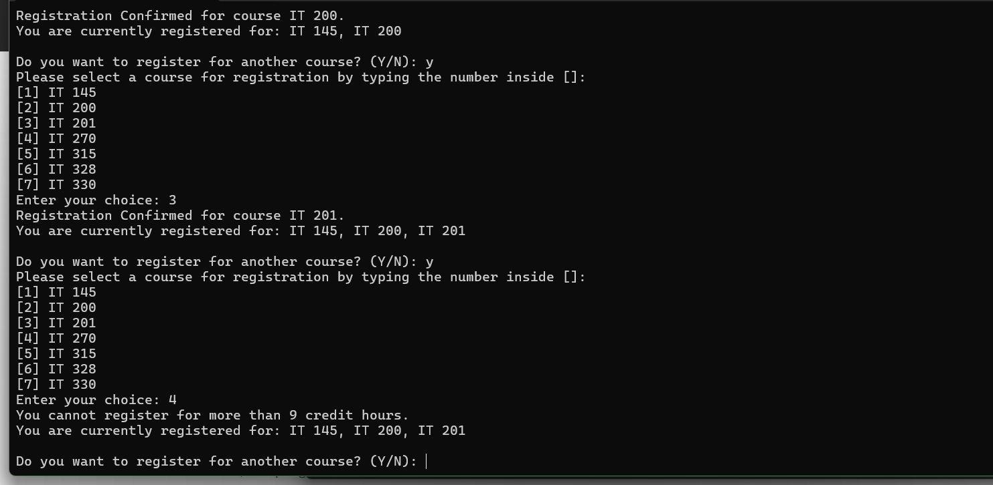

User cannot register for more than 9 credit hours.

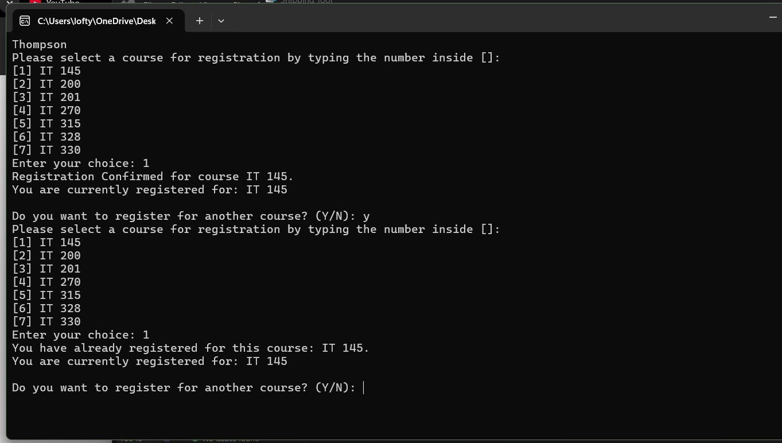

User cannot register for the same course twice.

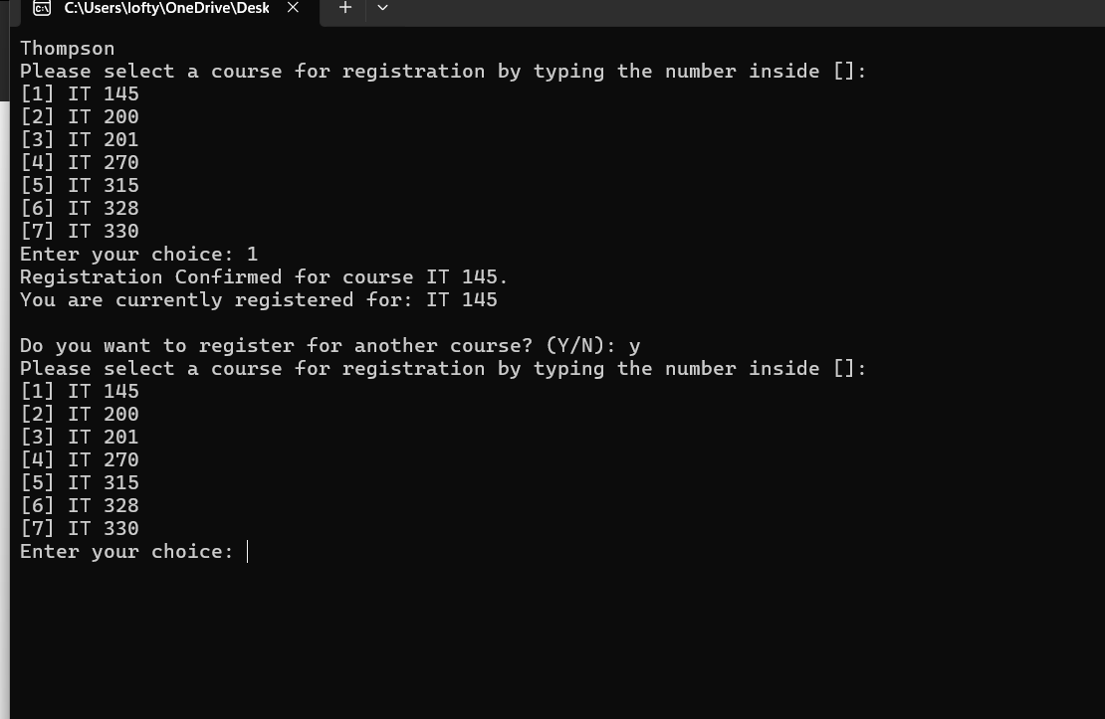

Only closes upon user command.

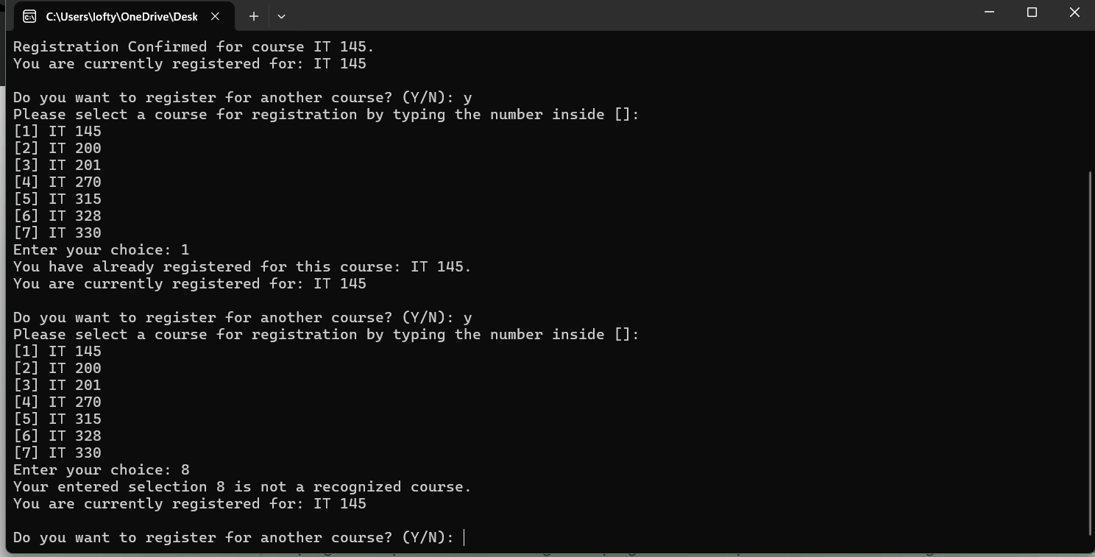

Only recognizes given input integers.

using System;

using System.Collections.Generic;

namespace ConsoleRegisterStudent

{

class Program

{

static void Main(string[] args)

{

(new Program()).Run();

}

void Run()

{

int choice;

List<int> registeredCourses = new List<int>();

int totalCredit = 0;

string yesOrNo;

Console.WriteLine("Thompson");

do

{

WritePrompt();

choice = Convert.ToInt32(Console.ReadLine());

int validation = ValidateChoice(choice, registeredCourses, totalCredit);

if (validation == -1)

Console.WriteLine("Your entered selection {0} is not a recognized course.", choice);

else if (validation == -2)

Console.WriteLine("You have already registered for this course: {0}.", ChoiceToCourse(choice));

else if (validation == -3)

Console.WriteLine("You cannot register for more than 9 credit hours.");

else

{

Console.WriteLine("Registration Confirmed for course {0}.", ChoiceToCourse(choice));

registeredCourses.Add(choice);

totalCredit += 3;

}

WriteCurrentRegistration(registeredCourses);

Console.Write("\nDo you want to register for another course? (Y/N): ");

yesOrNo = Console.ReadLine().Trim().ToUpper();

} while (yesOrNo == "Y");

Console.WriteLine("Thank you for registering with us.");

}

void WritePrompt()

{

Console.WriteLine("Please select a course for registration by typing the number inside []:");

Console.WriteLine("[1] IT 145\n[2] IT 200\n[3] IT 201\n[4] IT 270\n[5] IT 315\n[6] IT 328\n[7] IT 330");

Console.Write("Enter your choice: ");

}

int ValidateChoice(int choice, List<int> registeredCourses, int totalCredit)

{

if (choice < 1 || choice > 7)

return -1; // Invalid selection

if (registeredCourses.Contains(choice))

return -2; // Course already registered

if (totalCredit + 3 > 9)

return -3; // Exceeds credit limit

return 0; // Valid choice

}

void WriteCurrentRegistration(List<int> registeredCourses)

{

if (registeredCourses.Count == 0)

Console.WriteLine("You have not registered for any courses yet.");

else

{

List<string> courseNames = new List<string>();

foreach (int course in registeredCourses)

{

courseNames.Add(ChoiceToCourse(course));

}

Console.WriteLine("You are currently registered for: {0}", string.Join(", ", courseNames));

}

}

string ChoiceToCourse(int choice)

{

switch (choice)

{

case 1: return "IT 145";

case 2: return "IT 200";

case 3: return "IT 201";

case 4: return "IT 270";

case 5: return "IT 315";

case 6: return "IT 328";

case 7: return "IT 330";

default: return "Unknown";

}

}

}

}